CFIHOS RDL Development Guide

|  |  |  |
| --- | --- | --- |
| **Version** | **Date** | **Comments/History** |
| V01 |  | Initial revision with Chevron content, titled “Chevron Approach to RDL Alignment”   * Principles section * Guidelines section |
| V02 |  | BP modifications:   * Added Tagging criteria section * Updates to Principles and Guidelines section * Renamed to “BP Approach to RDL Alignment” |
| V03 |  | Shell modifications   * Added Background section * Added CFIHOS Submission section * Added Assessment Criteria section * Consolidated Guidelines section into Principles. * Updated Principles section to expand on the definition of the principles and provide examples * Updated Tagging Criteria section to compare criteria from BP, Chevron, and Shell * Renamed to “Consolidated Approach to CFIHOS RDL Alignment” |
| V04 |  | Modifications to clarify functional/physical classification of equipment   * Added Definitions section * Added Revision History section * Clarifications added for approach to functional and physical classes * Example classes updated to align with approach to functional and physical classes |
| V05 |  | Add description of difference between Tag (Functional) and Equipment (Physical) Classes. |
| V06 |  | Include rule changes agreed upon TOTAL joining group. |
| V07 |  | * Merger of existing ‘Consolidated Approach to CFIHOS RDL Alignment’ and ‘CFIHOS Properties Rules’ * Incorporate comments from review by expanded CFIHOS RDL Working Group |
| V08 | Oct 2024 | * Restructured due to addition of Document RDL entities. * Section added for Document Types and their Properties, from the previously unpublished Rules Document vD. * Section added for relationships between Document Types, Tag or Equipment Classes and Disciplines. * Added methodology for allocation of Asset Type Reference in Discipline Document Type. |

Acknowledgements

In 2012, Shell approached Netherlands-based process industry organization USPI to explore turning their corporate information standard into an industry-wide standard. The result was the CFIHOS (Capital Facilities Information Handover Specification) project.

Its aim is to offer practical, standardized specifications for information handover that work across the supply chain – operators, contractors and suppliers. The most recent CFIHOS industry standard (Version 1.4) was published in October 2019 by USPI with support from the Engineering Advancement Association of Japan (ENAA). This document, describing the scope and procedures of CFIHOS, is part of this standard.

Following a member vote in 2019, the future governance, development, and maintenance of the CFIHOS project and standard moved from USPI to IOGP in January 2020, becoming Joint Industry Project (JIP)36.

**Disclaimer**

Whilst every effort has been made to ensure the accuracy of the information  
contained in this publication, neither IOGP nor any of its Members past present or  
future warrants its accuracy or will, regardless of its or their negligence, assume  
liability for any foreseeable or unforeseeable use made thereof, which liability is  
hereby excluded. Consequently, such use is at the recipient’s own risk on the basis  
that any use by the recipient constitutes agreement to the terms of this disclaimer.  
The recipient is obliged to inform any subsequent recipient of such terms.

This publication is made available for information purposes and solely for the private  
use of the user. IOGP will not directly or indirectly endorse, approve or accredit the  
content of any course, event or otherwise where this publication will be reproduced.

**Copyright notice**

The contents of these pages are © International Association of Oil & Gas Producers.  
Permission is given to reproduce this report in whole or in part provided (i)   
that the copyright of IOGP and (ii) the sources are acknowledged. All other rights are  
reserved. Any other use requires the prior written permission of IOGP.

These Terms and Conditions shall be governed by and construed in accordance  
with the laws of England and Wales. Disputes arising here from shall be exclusively  
subject to the jurisdiction of the courts of England and Wales.

The Capital Facilities Information Handover Specification (CFIHOS) is an industry standard developed to improve information exchange between the companies who own, operate, and construct plants for the process and energy sectors. Starting with a common equipment naming taxonomy and supporting specifications, its goal is to become a common language for the exchange of information in these sectors.

The initial focus is on information, both structured data and traditional document formats, which are required be handed over when a project moves from its development to operations phase. Ultimately, the aim is for CFIHOS to become the de-facto standard for information exchange throughout the physical asset lifecycle, from conception through to decommissioning.

The Reference Data Library or “RDL” lies at the heart of CFIHOS. This library gives a standard and unified naming convention for equipment, its attributes, properties, disciplines and documents and relationships.

The CFIHOS RDL includes:

* A list of Tag classes and their definitions, describing what the equipment does
* A list of Equipment and their descriptions, describing the physical equipment item
* A list of properties
* List of disciplines document types
* Lists of properties of tags and equipment
* Pick lists (allowable values for data properties to aid validation)
* Units of Measure
* Relationships between data objects.

The initial CFIHOS RDL development approach document was developed by the Owner Operator RDL Alignment Team (bp, Chevron, Shell and TotalEnergies) and later expanded to include ExxonMobil and Equinor with a view to carry out a one-off alignment of their existing RDLs.

Following the growth in membership of CFIHOS community across the supply chain, the RDL development and governance document has been improved to accommodate input from wider stakeholders to drive consistency and clarity in the set of criteria to be applied in maturing the content of the RDL through feature requests.

**Contents**

1. Introduction 6

1.1 Definitions 6

1.2 Engineering Objects 6

1.3 Document Objects 7

2. Tag or Equipment Classes and their Properties 10

2.1 Criteria for Class Acceptance or Rejection 10

2.2 Procedure for Class Acceptance or Rejection 11

2.3 Assumption of Validity 15

2.4 Further Assessment Criteria 15

2.5 Criteria for Creating and Maintaining Properties 15

3. Document Types and their Properties 20

3.1 Criteria for Document Type Acceptance or Rejection 20

3.2 Procedure for Class Acceptance or Rejection 20

3.3 Assumption of Validity 20

3.4 Further Assessment Criteria 21

3.5 Maintaining Document Delivery Requirements 21

3.6 Creating and Maintaining Class Relationships 21

Annex 1 - Tag (Functional) Vs Equipment (Physical) Classification 24

Annex 2 - Tagging Criteria 27

**Figure List**

Figure 1: Taxonomy Mapping Between CFIHOS and Common Names 16

Figure 2: Example of Datasheet Showing Property Groups 18

Figure 3: Tag Class Property Metadata 19

Figure 4: Equipment Class Property Metadata 19

Figure 5: Model Part Class Property Metadata 19

Figure 6: Example SI Datasheet 24

Figure 7: Classification of Objects 25

Figure 8: Space-time map for coincident individuals (pump example from ISO 15926-2) 26

**Table List**

Table 1: Example of Tag Class to Equipment Class Mapping 7

Table 2: Example of Document Types 8

Table 3: Example of Discipline Document Types 8

Table 4: Example of Requirements Specified Against Discipline Document Type 9

Table 5: Example of Tag or Equipment Class Document Requirements 9

Table 6: Required Attribute for Tag Class or Equipment Class Request 14

Table 7: Tag/Equipment Class Hierarchy 15

Table 8: Property Entity Attributes 18

Table 9: Tagging Criteria 29

# 

# Introduction

This document describes the rules that shall be applied by the CFIHOS RDL Work Groups to identify equipment classes, their attributes, properties, document types, units of measurement, pick list of values and relationships, for additions, modifications or deletions in the CFIHOS RDL.

Each of the participating Companies have their own RDL/Class Library. To enable consensus and alignment of the Companies’ RDLs, each Company shall map their own RDL with the CFIHOS RDL. Each Company can then propose any changes considered necessary to the RDL Work Group for agreement through Feature Requests. Sections 2 and 3 provide further detail of the criteria for agreeing proposed changes.

## Definitions

1. A class represents a group of objects that have similar properties, behaviours and relationships as defined by the rules for membership of the class
2. The Tag Class represents the design intent or engineering specification
3. The Equipment Class represents the physical item, i.e. actual installed item
4. The Model represents what can be purchased to satisfy the function
5. The Document Class currently represents the document type as used by the associated discipline.
6. Property or attribute or characteristic are synonyms for a discrete item of data; it should have a unique name or label, a concise, unique and unambiguous definition or description, including data type and rules for acceptable population with a value. Property, Attribute and Characteristic are synonyms in the context of this document
7. Functional properties describe engineering requirements for design or purchase purposes
8. Physical properties describe standard equipment from a manufacturers catalogue or actual installed equipment.
9. Document delivery requirements describe format, templates, status and delivery timing for a document class.
10. Document properties describe the information about the document object (document master/ document revision).

## Engineering Objects

Engineering objects (e.g. Tags, Equipment or Model Parts) can be classified in CFIHOS to enable the grouping of similar objects and specification of common requirements. Tag (or Functional) and Equipment (or Physical) Class(es) are defined in the CFIHOS RDL, with a hierarchy to help to assign appropriate Class(es).

### Tag and Equipment Classes

Each Tag is classified by a “Tag Class” and the basic function (e.g. pump) that the object is intended or required to perform is captured as design information (e.g. flowrate). Once a physical object is selected to be installed at that function, an “Equipment Class” (e.g. centrifugal pump) is used to describe the actual capability and nature of the installed equipment (e.g. dimensions). These physical properties would change if the component was switched out for another, but the functional properties would not (see Annex 1 for further explanation).

The split between Tag (Functional) and Equipment (Physical) class is difficult to define. In the current version of the CFIHOS RDL the same class name is used for Tag and Equipment classes. Where the tag class and equipment class are not the same, mappings between the Tag and Equipment have been made, as shown in Table 1 below:

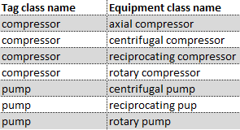

Table 1: Example of Tag Class to Equipment Class Mapping

The approach taken for the RDL is based on the assumption that a class can be either just a tag class, just an equipment class, or both. The split between functional and physical classes in a practical implementation will be one of how far down the class hierarchy you go before you move from functional to physical. E.g. pump could be functional where subclass centrifugal pump might be physical.

Simplistically, this will be interpreted as if the respective Owner Operator’s Tagging Specifications have a requirement for a functional class, it shall be considered as a valid Tag (Functional) class. This shall apply for items that traditionally have not been uniquely identified, for example Special Piping (SP) Items as well as uniquely identified tags. A high-level comparison of the Owner Operator’s Tagging Specs is shown in Annex 2.

This approach will be reviewed for continuous improvement to ensure that it is fit for purpose.

### Tag/Equipment Properties

Each class can have associated properties that describe some aspect of the Tag, Equipment or Model Part. Classes and Properties are created, populated and maintained in order to satisfy business needs (e.g. the ‘Voltage’ is a commonly used physical property for electrical equipment, as the value has a large impact on the maintenance routine for that piece of equipment). An object of a specific Class is placed in an operating environment in order to perform its function and it usually contains a product, for which the property ‘fluid phase’ (e.g. gas, liquid.) would be required.

## Document Objects

Each engineering object can have associated documents that provide information about the object in either unstructured or structured form. Some equipment industry standards describe the types of documents that are expected to provide information about the tag or equipment class, but this is mostly referenced in narrative form, can be ambiguous, and do not typically align to a document classification standard.

### Document Classes

A document is classified by a document class, called a document type. The document classification is designed to meet the following business needs:

* Provide a unique and consistent categorization of documents
* Enable search criteria for common facilities documents.
* Provide a baseline specification for delivery requirements including format, templates, metadata, status and delivery timing.

For effective search filtering, the classification must limit the results, but not be so specific that the document type criteria alone returns a single document in the search result. For example, a document type of ‘drawing’ would not narrow the search results where a major project can generate tens of thousands of drawings. In contrast, a document type such as ‘amine system operating procedure’ would likely return a single result. A document type of operating procedure can be used where the context of ‘anime system’ should be filterable through the document title or through cross-references between the document object and engineering objects.

The CFIHOS Document RDL recognises document types that support engineering objects as well as project management, execution and operations. Table 2 below shows some examples.

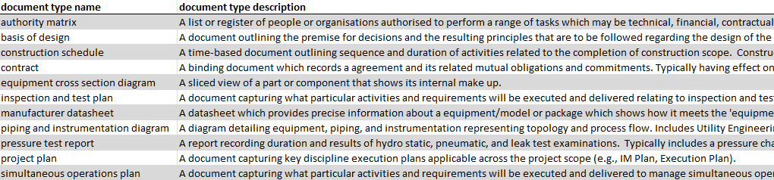

Table 2: Example of Document Types

CFIHOS identifies the document types that may be associated with disciplines. As well as providing additional search filter capabilities, this can be used for designating responsibilities for development and distribution of document types within discipline roles on a major project or in an operating facility. Table 3 below shows some examples.

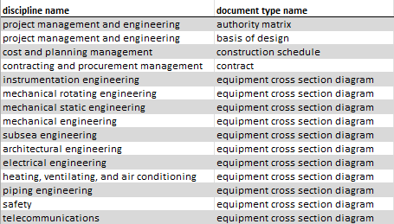

Table 3: Example of Discipline Document Types

### Document Delivery Requirements and Properties

The delivery requirement properties are currently specified in the discipline document type entity. In a future release of CFIHOS, these shall be applied at the document type entity level, since the specified requirements may not differ for each associated discipline. CFIHOS recognises that there may be other criteria than just the document classification that may determine the delivery requirements. For example, an owner operator may only require a document type to be delivered and maintained “as-built” when the content of the document addresses a critical engineering object. The CFIHOS document handover requirements can be used against the document classification or specified with those conditions identified. Table 4 below shows some examples of document delivery requirements against discipline document type.

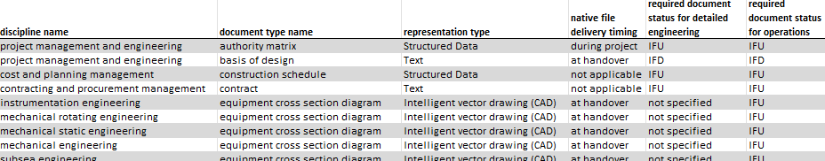

Table 4: Example of Requirements Specified Against Discipline Document Type

Document properties are delivered with the document object during a project and maintained in a document management system. These are defined in the document master and document revision entities. The RDL property picklists define values that should be used for some of these properties.

### Tag or Equipment Class Document requirements

An objective of the CFIHOS Document RDL development is to provide minimum document requirements for all CFIHOS tag and equipment classes, complimentary to the structured data and model requirements for a facility. CFIHOS identifies the types of documents that may be associated with tag or equipment classes to inform document requirements, referencing source standards like IOGP JIP33 wherever applicable. Table 5 below shows some examples.

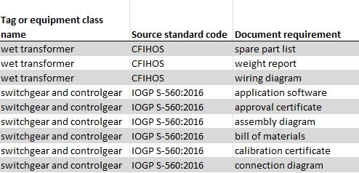

Table 5: Example of Tag or Equipment Class Document Requirements

# Tag or Equipment Classes and their Properties

## Criteria for Class Acceptance or Rejection

The initial CFIHOS RDL classes were built upon, and shall be maintained based on the following:

### A Class is accepted when it reflects:

1. Different Classes (Functional or Physical) must have different sets of properties. If this is not the case, then there is no reason to have a different Class. Example:
2. Tag (functional) class “electric motor” does not have the same set of properties, as an “electric generator”, so two distinct classes are required except as mandated by legislation or relevant international standards.
3. Equipment (physical) class “Centrifugal Pump” shares the same properties, as a “Multistage Centrifugal Pump”, only the value for the property ‘Number of Stage’ would be different, so only one class is required, the most generic one.
4. In case of measurement devices (e.g. instruments), the class name may contain the measured variable (e.g. “pressure transmitter”).
5. The method (physical process) used to perform the function. In order to perform the function different methods (e.g. geometry, physical effect) can be used. Different methods imply different detailed properties, this means that in that case more than one class is required to group these properties. Examples:
   * An object of equipment class “Centrifugal pump” uses the centrifugal force in order to perform the “pump” function.
   * Objects of equipment class “Plate heat exchanger” and “shell and tube heat exchanger” are fundamentally different in shape
6. The primary function performed by the object. For example, “ventilation fan” and “cooling fan” are in fact “fans” that performs different secondary functions,” ventilating” and “cooling”, but the primary function of a “fan” is to create a flow of gas. This flow of gas may be used to “ventilate” or to “cool”.
7. In this particular case, the object performing the function should be contained in the name, description or properties in the corresponding secondary function. In the previous example, the Tag description (service) could be “Main Control room ventilation fan” and the Functional Class of the Tag would be “fan”. The physical class could be “centrifugal fan” or “axial fan”, describing the actual type of fan installed to perform the function
8. If the installed object has different maintenance requirements, different physical classes may be required, e.g. “gas turbine” vs “steam turbine”.

### A Class name is rejected when it:

1. Contains the location where the classified object will be installed (e.g. “deep well pump”) or is ambiguous – e.g. subsea control panel is unlikely to be installed under water.
2. Contains the dimensions of the classified object (e.g.”5-inch valve”).
3. Contains the material that is used to build the object (e.g. “stainless valve”).
4. Makes reference to the product properties that could be contained within the Object (in term of physical variables like pressure, flow, temperature or fluid type) unless its primary function is to measure these physical variables (e.g. “chemical tank” would be rejected because it could be used for storing other contents, for example diesel).
5. For measurement devices, contains the Unit of measure used to measure the variable (e.g. PSI pressure transmitter).
6. Contains a term that is part of an infinite series of terms which would result in the creation of an infinite number of classes. (e.g. “CO2 gas detector” is rejected because CO2 is one combination of molecules and there are an infinite number of molecules combinations).
7. Is intended to classify objects of different natures, i.e. “catch-all” type of classes (e.g. “Other mechanical equipment”)
8. Is a Tag Class, with the ‘Equipment Installed’ attribute set to yes, that does not have any mapped physical classes.
9. Is a Functional Class at the lowest level of the hierarchy that is not used by any of the Owner Operator RDL Alignment Team members (See 2.4.1).
10. Contains an abbreviation in the Name
11. Shares the same definition as another class (provision is available in CFIHOS to capture a synonym).
12. Is a Tag or Equipment class with only one child at the lowest level of the hierarchy.

## Procedure for Class Acceptance or Rejection

CFIHOS members’ proposal submitted through CFIHOS Feature Request (FR) process shall be assessed based on the criteria defined in Section 2.1 to enable consensus.

1. The proposing member is responsible for
   1. submitting a Feature Request regarding their proposal
   2. ensuring the proposed class meets the criteria described in Section 2.1.
   3. providing all relevant information to support CFIHOS members voting regarding the overall principle of the FR.
2. Provided the proposed change meet the criteria and supported by majority of RDL Work Group members, the change will be submitted to the CFIHOS RDL FR Maintenance Team for inclusion in the CFIHOS RDL.
3. If a majority is not achievable, proposed change will be deferred or outrightly rejected. The outcome will be reported to the CFIHOS RDL FR Maintenance team as “not approved” along with the reason for rejection documented (in case it is proposed again in the future).

### Completion of Mandatory fields

Defined in the CFIHOS Tag/Functional Class and Equipment/Physical Class definitions, the fields in Table 6 are considered mandatory and additions will not be proposed if these fields cannot be completed (Source: CFIHOS V1.5).

| **Tag Class** | | | |  | **Equipment Class** | | | |
| --- | --- | --- | --- | --- | --- | --- | --- | --- |
| **Attribute Name** | **Definition** | **Constraint** | **Mandatory**  **Primary Key** |  | **Attribute Name** | **Definition** | **Constraint** | **Mandatory**  **Primary Key** |
| parent tag class name | Identify the parent class of a Tag Class, in order to build a hierarchy of Classes. | Refer to definition group: Tag Class | M[1] |  | parent equipment class name | Identify the parent class of an Equipment Class, in order to build a hierarchy of Classes. | Refer to definition group: Equipment Class | M1 |
| tag class name | The full name of the Tag Class. |  | PK |  | equipment class name | The full name of the Equipment Class. |  | PK |
| tag class definition | Definition of the Tag Class. |  | M |  | equipment class definition | Definition of the Equipment Class. |  | M |
| abstract class flag | When set to No, indicates that the Class can be used for classifying Tag, Equipment or Model_Part. If set to Yes, indicates that the Class can only be used for building a class hierarchy. | See Picklist: yes no | M |  | abstract class flag | When set to No, indicates that the Class can be used for classifying Tag, Equipment or Model_Part. If set to Yes, indicates that the Class can only be used for building a class hierarchy. | See Picklist: yes no | M |
| ISO15926 part4 unique number | The identifier used in ISO 15926-4 to identify this class uniquely. |  |  |  | iso15926 part4 unique number | The identifier used in ISO 15926-4 to identify this class uniquely. |  |  |
| CFIHOS unique id | A unique id number assigned by the CFIHOS project. |  |  |  | CFIHOS unique id | A unique id number assigned by the CFIHOS project. |  |  |
| unique id STEPLIB | The identifier used in Steplib to identify this class uniquely. |  |  |  | unique id steplib | The identifier used in Steplib to identify this class uniquely. |  |  |
| unique id POSC CAESAR | The identifier used in POSC-CAESAR to identify this class uniquely. |  |  |  | unique id posc caesar | The identifier used in POSC-CAESAR to identify this class uniquely. |  |  |
| referenced standard | International or Industry Standard that requirement is sourced from. |  |  |  | referenced standard | International or Industry Standard that requirement is sourced from. |  |  |
| tag number format | A regular expression that represents the tag class format according to Principals Tagging Specification |  |  |  | spare part info req | Indicate if some spare part information is required for this type of Equipment. | See Picklist: yes no | M |
| equipment installed | Indicate if equipment is expected to be installed for this type of Tag. | See Picklist: yes no | M |  | reason for having class | To provide the Reason for having the Class. |  |  |
| reason for having class | To provide the Reason for having the Class. |  |  |  |  |  |  |  |

Table 6: Required Attribute for Tag Class or Equipment Class Request

### 

## Assumption of Validity

Each company has invested time and expertise into their respective class libraries – suggestions should be accepted provided that they meet the defined criteria.

## Further Assessment Criteria

### Valid Business Need

A valid business need must be demonstrated before proposing a new class. The standard rule is that the class must be in use at more than one asset to consider adding (this may be across OOs). If only in use in one asset, then the class would be considered as project/asset specific and the OO can still use in their local library until usage increases.

### Reference to International or Industry standard

Proposed new classes should (wherever possible) be described in an international or industry standard/reference, preferably ISO 15926 Part 4 and/or other standards (for example API, ISO, IEE, ISA).

### Hierarchy maintenance during class removal

Where the list of child classes of a parent class reduces into one class, such parent class ceases to be a parent class. However, such parent class could be restored where additional class(es) are proposed and accepted to the list of child classes in the future.

### Duplication of classes

New classes must not be proposed that are synonyms of existing classes. Synonyms may be added to existing classes to allow for variations between companies/regions. Such synonym cannot be used for more than one class.

### Specialization

All classes shall be added whenever possible to the existing CFIHOS class hierarchy. Where possible this should maintain consistency with the existing granularity within CFIHOS.

|  |  |  |
| --- | --- | --- |
| **Class** | **Sub Class** | **Sub Sub Class** |
| Valve | Ball Valve |  |
| Transmitter | Pressure Transmitter |  |
| Analysing instrument | Chromatograph | Gas chromatograph |

Table 7: Tag/Equipment Class Hierarchy

The decision on where to stop the sub classification can be made by applying the rules described in this document (rule R.12).

## Criteria for Creating and Maintaining Properties

The initial CFIHOS RDL classes and properties were built upon, and shall be maintained based on the following:

### Criteria to decide the creation of a new property.

1. The property must appear on an international or industry standard or datasheet (See rule P.10 for how to deal with inconsistent property naming in existing standards).
2. The property will be used for the purposes of reporting (e.g. Ex register), searching, calculations or sharing (e.g. common data between CMMS and Inspection Management System). The property may have multiple purposes, i.e. for multiple consuming organizations and/or data systems. Purpose(s) must be explicit.

N.B.: CFIHOS does not try to include all data sheet fields on a datasheet, only those where a specific business requirement exists to hold the value as data will be included.

1. The property shall be related to at least one tag Class or one equipment Class or one CFIHOS Data object (i.e. no property will be unused).
2. The same property name can be used for both Tag (Functional) and Equipment (Physical) classes. For example, explosion protection gas group are required to define the EX requirement (functional) and the suitability of the equipment for use (physical). The Functional and Physical properties can be compared to partially automate the verification of the requirement.

### Rules for naming a new property.

1. Each property shall have a unique name and unique definition.
2. Abbreviations and special characters (e.g. /) shall be avoided in property names.
3. Figure 1 below illustrates the usage of the terms ‘upper limit’, ‘lower limit’, ‘normal’ and ‘rated’.

|  |  |
| --- | --- |
| **CFIHOS Name** | **Common Name** |
| Upper limit allowable pressure  Upper limit design pressure  Upper limit operating pressure  Rated pressure  Normal operating pressure  Lower limit operating pressure  Lower limit design pressure  Lower limit allowable pressure | Maximum allowable working pressure  Upper design pressure  Maximum operating pressure  Operating pressure  Lower design pressure  Minimum allowable working pressure |

Figure 1: Taxonomy Mapping Between CFIHOS and Common Names

**Some Definitions:**

* The values for ‘allowed’ are set by regulatory requirements.
* The value for ‘rated’ is the value at which the equipment has been designed to operate most efficiently.
* The value for ‘normal operating’ is the value at which the equipment will operate most of the time.

**Note:**

* The above example is for pressure but is applicable to any measured variable.
* The terms ‘normal design’ and ‘rated design’ are not allowed. The term ‘rated’ is used instead.

1. The name used for a property of a ‘part’ should contain the:
   1. Role of the part within the whole (e.g. inlet)
   2. Class of the part (e.g. flange) – see note below
   3. Property name (e.g. diameter)

Concatenating these words gives the name of the property ‘inlet flange diameter’.

**Note:** ‘Part’ should not be used to capture properties for tagged items (i.e. items that have a class defined in the Tag Class reference data). For example, in a package, pumps shall be uniquely tagged. Properties should therefore be associated against the pump tag and not the package tag, hence eliminating the need for a pump capacity property against the package. Components of the pump, for example the impellor, the casing can have properties created, i.e. casing material, impellor diameter, etc.).

1. The property name should be very specific (e.g. on a shell and tube heat exchanger ‘shell side fluid name’ is preferred to ‘fluid name’), unless this is the fluid in the whole assembly. This allows one:
   * + - To re-use the property for another class and to have a precise non-ambiguous definition.
       - To add more properties in the future without having to rename the existing ones (e.g. if ‘fluid name’ was created instead of ‘shell fluid name’, then it would be hard to introduce at a later stage a property for the ‘tube fluid name’).
2. Where possible, property names should align with international or industry standards (e.g. ISO-13709 for centrifugal pumps). Ideally the names would be the same but there are many inconsistencies in the engineering standards today that prevent this, so a reference to the source property name shall be retained where the property has different names in separate standards.
3. The word ‘Type’ shall be used in an unambiguous way, e.g. ‘actuator type’ is not a good property name as it could be referring to many aspects of the actuator; the signal type, the type of motion (linear or rotary) or the type of actuation, etc.

### Rules for describing metadata for a new property.

1. The property definition should be detailed enough to avoid ambiguities. The definition must not be a simple repetition of the property name or synonyms thereof. The definition should use terminology that can be understood by people from any discipline/background.
2. When a new property requires a unit of measure, it must be associated with a valid unit of measure dimension (for example temperature) which would allow for the specific uom (for example degrees Celsius or Kelvin).
3. Pick lists should be used when there is a finite list of well-defined values or options. Free text should be used when there is potentially an infinite number of options e.g. a property like ‘gas composition’ is not suitable for a pick list as there are too many possible values options to list.
4. The use of lookup values for property shall be maximized whenever possible and reference to the corresponding standard, if exist mentioned (e.g. explosion protection concept property lookup values are referenced back to EN 50014).
5. The property shall be mapped to one and only one ISO15926/PCA Property (check date – based on)
6. CFIHOS shall not capture the mapping between the property name and the equivalent name in other applications (e.g. CMMS, Corrosion/Inspection System, and Commissioning Completions Management System). If this mapping is required, it will be retained by each Owner Operator as the number of variations is too large to handle within the standards.

See the CFIHOS Data Dictionary for latest Meta data, shown in Table 8.

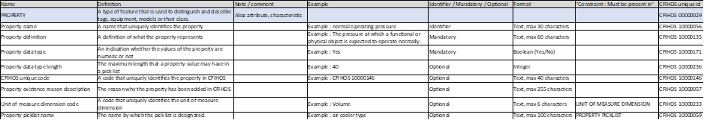

Table 8**: Property Entity Attributes**

**Note:**

Additional meta-data requirements would be considered as part of future maturation of CFIHOS standard for properties. Examples include:

* Required at Maturity Level – to indicate when in the lifecycle the property needs to be provided. For example, At end of FEED, prior to procurement, after procurement, etc.
* Attribute Group – to group properties as they are on a typical data sheet. The example below in Figure 2 shows an example for Air Cooled Heat Exchangers from ISO 13706, where properties are group into “Basic design data” and “Performance data – tube side”.

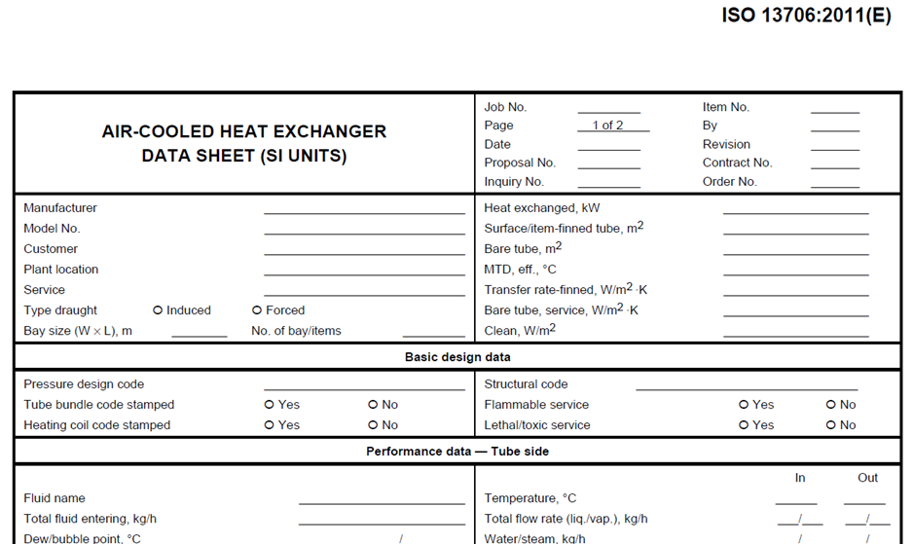

Figure 2: Example of Datasheet Showing Property Groups

### Rules for assigning properties to classes.

1. Properties can be assigned to a Tag, Equipment or Model Part. The property must appear on an international or industry standard or datasheet for the class to be assigned.
2. For new properties, the international or industry standard or datasheet defining the relationship between the class and the property must always be identified.
3. Default units of measure will be assigned based on the values from the relevant standard.

See the CFIHOS Data Dictionary for latest Meta data. Below are examples:

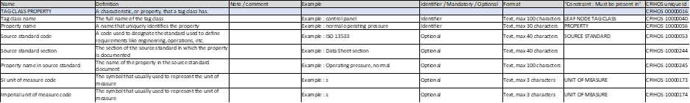

Figure 3: Tag Class Property Metadata

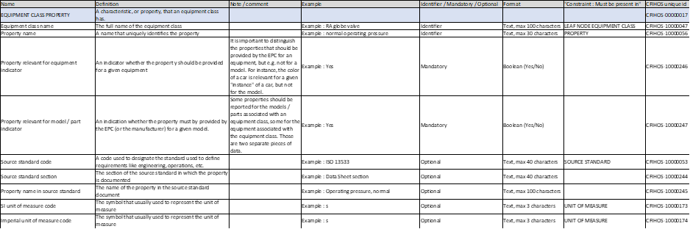

Figure 4: Equipment Class Property Metadata

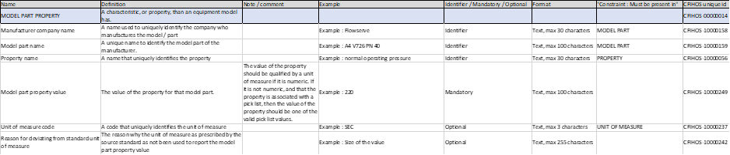

Figure 5: Model Part Class Property Metadata

# Document Types and their Properties

## Criteria for Document Type Acceptance or Rejection

The initial CFIHOS RDL Document Types were built upon, and shall be maintained based on the following:

### A Document Type is accepted when it:

1. Enables document search where a reasonably small number of results will be returned.
2. Reflects a common deliverable type recognized by other industry standards and that does not conflict with other criteria described in this section.

### A Document Type is rejected when it:

1. Shares the same or a similar definition as an existing document type (provision is available in CFIHOS to capture a synonym).
2. Describes a single deliverable on a project unless it is a critical part of the asset lifecycle.
3. Contains the discipline of the described deliverable, e.g., Cost and Schedule Report.
4. Contains an equipment class in the name, e.g., Centrifugal Pump General Arrangement.
5. Contains the format of the described deliverable, e.g., Installation PDF.
6. Uses vendor or proprietary references, unless used as an example in the document type description to clarify intent.
7. Contains an abbreviation, acronym or special characters.

## Procedure for Class Acceptance or Rejection

CFIHOS members’ proposal submitted through CFIHOS Feature Request (FR) process shall be assessed based on the criteria defined in Section 3.1 to enable consensus.

1. The proposing member is responsible for
   1. submitting a Feature Request regarding their proposal
   2. ensuring the proposed class meets the criteria described in Section 3.1.
   3. providing all relevant information to support CFIHOS members voting regarding the overall principle of the FR.
2. Provided the proposed change meet the criteria and supported by majority of Document RDL Work Group members, the change will be submitted to the CFIHOS RDL FR Maintenance Team for inclusion in the CFIHOS RDL.
3. If a majority is not achievable, the proposed change will be deferred or outrightly rejected. The outcome will be reported to the CFIHOS RDL FR Maintenance team as “not approved” along with the reason for rejection documented (in case it is proposed again in the future).

### Completion of Mandatory fields

Any proposed document type should be submitted with a concise name, clear definition and include any known synonyms.

## Assumption of Validity

Each company has invested time and expertise into their respective class libraries – suggestions should be accepted provided that they meet the defined criteria, including those below.

## Further Assessment Criteria

### Valid Business Need

A valid business need must be demonstrated before suggesting a new document type or discipline for addition to the RDL. The standard rule is that the document type must be reasonably anticipated to be generated on a project to consider adding (this may be across OOs). If only one example can be cited, then the document type would be considered as project/asset specific and the OO can still use in their local library until usage increases.

### Reference to International or Industry standard

Proposed new classes should (wherever possible) be described in an international or industry standard/reference (for example IOGP JIP33, ISO 15926 Part 4, API, ISO, IEE, ISA).

### Duplication of Document Types

New Document Types must not be proposed that are synonyms of existing Document Types. Synonyms should be added to existing Document Types to allow for variations between companies/regions. Such synonyms cannot be used for more than one Document Type.

## Maintaining Document Delivery Requirements

### Document Delivery Requirements

The delivery requirements are currently specified in the discipline document type entity. In a future release of CFIHOS, these shall be applied at the document type entity level, since the specified requirements may not differ for each associated discipline.

Delivery requirements appear also in the *source standard document and data requirement* part of the RDL and are defined based on the tag or equipment class association and content description in the source standard. It is recognised that these may differ from those applied against discipline document type and in these cases, the source standard requirement should be applied.

### Document Properties

Document properties are delivered with the document object during a project and maintained in a document management system. Document properties are defined in the document master and document revision entities. The RDL lists property, property picklists and property picklist values to support the capture of document properties. Any proposed new (or changes to) properties or picklist values shall be submitted via FR detailing the business case and clear definitions where applicable. New document properties are not eligible where they are already captured as a reference or relationship within CFIHOS.

## Creating and Maintaining Class Relationships

### Document Types and Disciplines

Document classification systems frequently limit the combination of discipline and document type associations where such a deliverable is common and well understood, e.g. a piping and instrumentation diagram under a process engineering discipline. In other cases there are no rules for which document types can be associated with which disciplines. The Document RDL Team established the relationships between document type and the CFIHOS disciplines in agreement between the Owner Operator representatives for release v1.4 using the following criteria:

* If the discipline typically has responsibility to generate a document, it would belong to the discipline.
* The discipline list shall include a discipline code, a name, and a well-articulated description that clearly describes the intent and scope of the discipline.
* Discipline lists shall avoid the use of any special characters which may be affected by, or can affect software code (i.e. apostrophes, asterisks, underscores, brackets, etc.). Limiting names and descriptions to only alpha characters is preferred.
* The discipline listing shall utilize terms most commonly used in the industry but refrain from using abstract terms where different owner operators may have different definitions (e.g., Project Services)
* Academically grounded disciplines shall be used to the greatest extent possible aligned with the practical specification and documentation related to the asset
* Project Activities/Management specific disciplines are used to distinguish document types to describe multi-discipline deliverables
* The discipline listing shall avoid duplicative and/or overlapping where more than one choice could be logically “correct”
* The discipline list shall consider adjusting granularity based on the volume of document types allocated to a single discipline, the intent being to allow for easier review by an individual of all document types available in a single discipline.
* The discipline list shall remain aligned with the scope around a data exchange standard between Owner Operators and EPC Contractors/Suppliers.
* The discipline code shall be comprised of two alpha characters - this remains in line with the current CFIHOS standard. Each code must be unique

### Asset Type Reference

The asset type reference provides a basis for provision of structured cross reference data between document numbers and their associated assets. The asset type reference is currently specified in the discipline document type entity but will in a future version of CFIHOS be applied at the document type entity level as described in Section 3.5.1.

The values are applied to document types (discipline document type) based on the methodology below:

a. Document types are allocated to model_part when the content is likely to reference specific model/s or part/s and not just equipment tags. E.g., manufacturer datasheet, certificates, equipment cross-section diagram, bill of materials, spare parts list.

b. Document types are allocated to equipment when the content is likely to reference tag numbers for physical tags. E.g., assembly diagram, performance report, factory acceptance test records.

c. Document types are allocated to tag when the content is likely to reference tag numbers for functional tags. E.g., process flow diagram, material selection diagram, maintenance strategy, purchase order.

d. Document types are allocated to process unit when the content is likely to reference process_units but not tag numbers specifically. E.g., process control narrative, system study.

e. Document types are allocated to plant when content is likely to be specific to a plant but unlikely to reference specific process unit, tag, model, or part numbers. E.g., design basis and some other philosophies, business processes, general document types etc.

f. Document types are allocated to site when content is likely to be specific to a site. It may reference plant/s but also a broader geographical area. E.g., ice analysis study, environmental impact assessment, philosophies, business processes etc.

The asset type reference is indicative and may be applied by the user against tag or equipment classes even where it is suggested to be applied against a different asset type, e.g. process_unit or plant. It may be used to distinguish where the associated document represents functional tags or physical equipment.

### Document Types and Equipment or Tag Classes

The Document RDL Team establish the relationships between document type and tag or equipment class. Source standards shall be used where an MOU is established between CFIHOS and the source standard (e.g. IOGP JIP33, EPIM STI). Source standard delivery requirements will be included where available.

New relationships may be developed using member benchmarked data, for example from internal VDDR/SDRLs which should be mapped to the equivalent CFIHOS tag, equipment and document classes. The asset type reference shall be used to validate appropriate allocation of document type based on mapping

Annex 1 - Tag (Functional) Vs Equipment (Physical) Classification

PROJECT REQUIREMENTS

During a Project the design of the asset is progressively decomposed into functional items until a sufficient level of granularity is achieved to enable procurement of equipment. These lowest level functions are allocated a unique identification number per plant, known as a Tag.

Different functions have different requirements, for an example a pump and a motor will be represented with different symbols, have different tag formats and have different data and document requirements to progress the design and subsequent execution of the project. To allow these differences to be managed the Tags are classified.

The classification of the Tag may become more explicit as the Project progresses, so in FEED it may be known that a pump function is required but only when further specification of the requirements are defined in EXECUTE will it become clear that a centrifugal pump is most suitable for the required function. This will result in a functional specification defining the design and operating conditions that can be used to determine the physical items that most effectively meet the functional requirement for procurement.

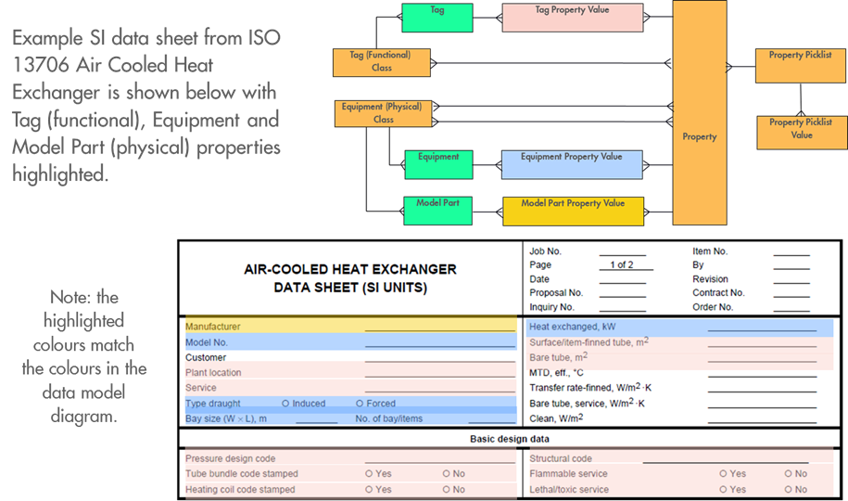

Figure 6: Example SI Datasheet

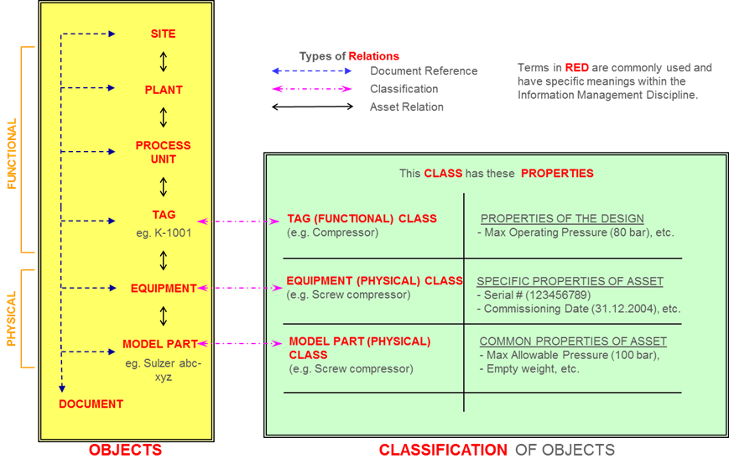

Figure 7: Classification of Objects

Vendors will offer either a custom designed item or a standard model part that can meet or exceed the functional requirements. This allows the selection of the physical equipment that will be procured to be installed to satisfy the function. These physical items typically have a serial number to uniquely identify them and can be classified with an equipment (Physical) class based on the technology used to satisfy the requirements (a pneumatic motor will have different properties to an electrical motor for example). To complicate matters the data sheets for these different items often mix tag and equipment properties in the same document.

**OPERATIONAL REQUIREMENTS**

Once the plant is handed over to Operations, the main focus is to ensure that the asset continues to function as designed. Different functions will require different activities to be performed to achieve this based on the likely failure modes. Maintenance and Inspection activities are defined in the Maintenance System and typically scheduled at the functional level with costs and history subsequently recorded.

For some functions, for example pressure vessels, it is difficult to distinguish between the functional and physical. Other functions being able to be replaced, for example a relief valve could be removed and another equivalent relief installed to provide the same function. With this example of a relief valve it is important to ensure that the certification of the specific valve installed is known to ensure it is configured correctly. ISO 15926-2 contains an equivalent example for a pump shown in Figure 8.

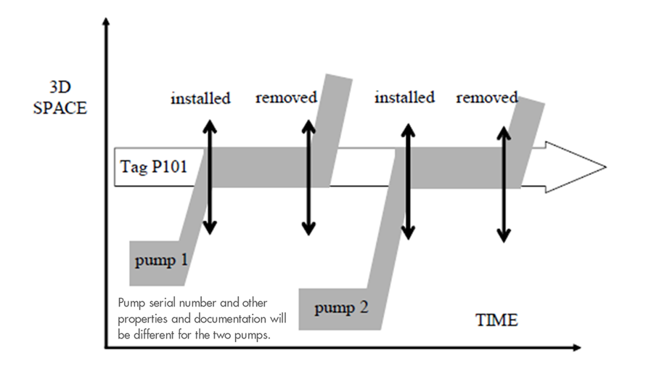

Figure 8: Space-time map for coincident individuals (pump example from ISO 15926-2)

The Tag (function) would only change if there was a plant change to change the functional requirement.

To put very simplistically a Tag is description of the function required, while the equipment is something that can be touched and is installed to satisfy the function.

Annex 2 - Tagging Criteria

Table 9 below provides a high-level comparison of typical Owner Operator’s Tagging Requirements.

|  | **BP** | **Chevron** | **Shell** | **TotalEnergies** |
| --- | --- | --- | --- | --- |
| Operations | to identify specific equipment for isolation purposes (electrical and process) in relation to operational procedures. | requires identification in one or more operational procedures.  Subject to isolation procedures such as permit to work (PTW) (e.g., electrical equipment, manual valves, and piping specialty items). | to identify specific equipment for isolation purposes (electrical, process and utilities) in relation to operational procedures. | Tags shall be allocated to Asset objects up to a certain level of the Asset decomposition, allowing to manage efficiently & in a practical way Company activities and associated technical information.  Tags can be allocated to single objects or group of objects, subject to site construction/installation, pre/commissioning, operations, inspection and/or maintenance.  • All Safety Critical Elements shall be tagged.  • Any other item or object installed permanently at a worksite, which is handled during one or several of above activities shall be allocated a dedicated tag by Contractor.  • Temporary items or objects supporting some of above activities may also be tagged for close follow up of their status over time |
| Maintenance | the need to perform maintenance activities on an equipment item, that will require scheduling of maintenance and/or equipment history recording at that level of detail. | subject to inspection, maintenance, or history.  Includes pipe supports with maintainable components (e.g., springs, dampers, and polytetrafluoroethylene [PTFE) guides). | the need to handle or perform maintenance activities on an equipment item or line that will require scheduling of maintenance, inspection and/or equipment history recording at that level of detail. |
| Certification | pressure regulation, mechanical handling safe working load, etc. requirements for specific equipment. All EX certified electrical equipment within sub-contractor and/or supplier packages or modules must be allocated a project tag number except for IS barriers and cable glands. | are EX-rated, used in a hazardous area, or used for mechanical handling).  Subject to compliance or regulations. | pressure regulation, hazardous area rated, mechanical handling safe working load, etc. requirements for specific equipment. |
| Safety | equipment which performs a safety function, e.g. pressure relief valves and over-pressure protection devices. | Related to safety, including both process safety and life support | ‘Equipment items’ that perform a safety function, e.g. pressure relief valves, over-pressure protection devices, safety instrumented systems and fire-fighting devices. |
| Commissioning | The need to perform detailed functional checks and system start-up activities. |  |  |
| Engineering |  | Connected to permanent cables.  Includes inline piping equipment, devices, and components (e.g., manual valves and piping specialty items). |  |
| Spares |  |  | ‘Equipment items’ that require tag numbers to allow Bills of Materials to be related to them. |
| Technical Documentation |  |  | Technical documents require references to Tags to be collected to facilitate finding key information in the Operate Phase |

Table 9: Tagging Criteria

1. All new classes proposed will be provided with a Parent Class to ensure that it can be added to the existing hierarchy.